INTRONIK STF
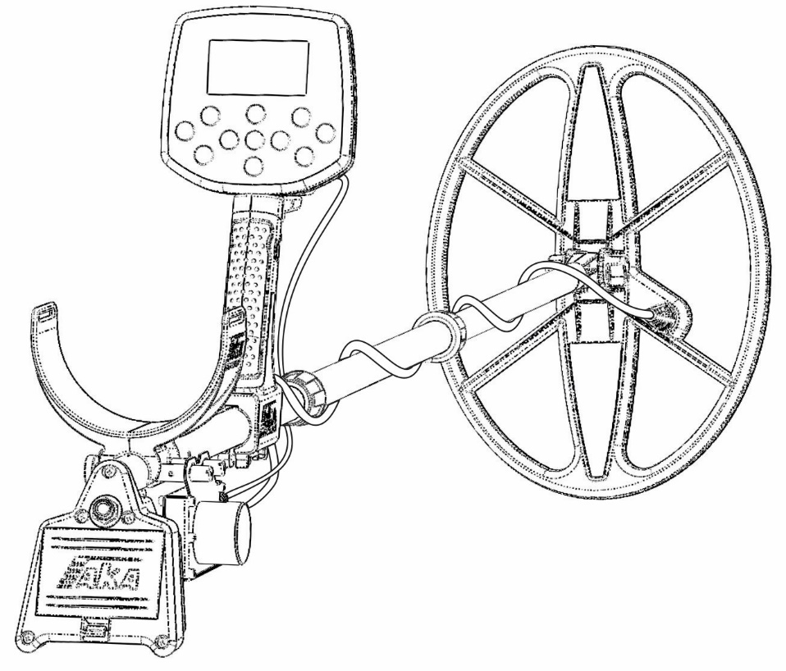
Computerized Selective Two-Frequency Metal Detector
User Manual. Version 2.0 Final

Russia, Moscow 2025

https://aka-md.com/ e-mail: akadetector@gmail.com

Table of Contents
Important Information 3
General Device Description 3
Powering the Intronik STF 3
Preparing the Device for Operation 4
Assembly Procedure 4
Controls and Connectors 7
Metal Detector Control Panel 8
Trigger 9
Information on the Screen 10
Preparing the Metal Detector for Search 11
Ground Compensation 12
Programs Requiring Ground Balance 15
Ground Evaluation Program 16
Ground Evaluation Table Data 17
“Quick Start”. Factory Programs using the Ground Compensation Method 19
Additional Specialized Factory Search Programs 19
Settings 21
«М» Menu. Basic Search Settings 22
«М1» Menu. Noise and False-Signal Filters 23
«А» Menu. Audio Menu. Main Audio Settings 25
«А1» Menu. Additional Audio Menu. Tone and Tone Boundary Settings 27
«АМ». Menu. Discrimination and Identification Settings Menu 27
Enabling and Disabling 2F ID Discrimination in Search Mode 28
«V» Menu. Video/Display Settings 30
«V1» Menu. Additional Video Settings 31
Extended Explanation of Target Information on the Screen 31
Hodograph Explained 32
Simultaneous analysis of HF and LF Hodographs 33
Digital Target Information 36
Firmware Update 38
Useful Links 40
Warranty Terms 40
Conditions for Loss of Warranty 40
Warranty Card 41
Sale and Release Data 41

Important Information
The manufacturer reserves the right to make changes to the design, packaging, or manufacturing technology of the product without prior notice to the buyer to improve its properties. This manual may contain typos in text and numerical designations. Should you have any questions about the operation and use of the device after reading the manual, please contact the seller or a specialized service center for additional information.

General Device Description
The Intronik STF metal detector is designed for searching and identifying metal objects in dielectric sites (dry sand, wood, etc.), low conductive sites (damp soil, saline soils), and weakly conductive sites (soils with magnetic mineralized soils, brick walls, etc.).

The device may be applied:
- In forensics;
- In military engineering;
- In housing and communal services, construction, and firefighting for locating underground utilities, pipelines, cables, manhole covers, etc.;
- In archaeology and treasure hunting.
The device is intended for operation in the following conditions:
- Ambient temperature between -10 and +40°C;
- Relative humidity up to 98% at 25°C;
- Atmospheric pressure between 650 and 800 mmHg.
- The coil can be immersed in water, which must not enter the control unit, power supply unit, or the coil electronics unit.

Intronik STF Power Supply.
The Intronik STF metal detector operates when connected to a DC power source with a voltage from 6.5 to 12 V.
The design allows for the use of two 18650 type Li-Ion batteries (via the included adapter) or two 26650 type Li-Ion batteries.
The device consumes approximately 270-360mA (depending on the frequency pair of the searchcoil used) with headphones connected. When using the metal detector without headphones, with sound through the built-in speaker, the device's consumption increases.
It is recommended to use branded Li-Ion 18650(26650) batteries with a capacity of 3000mAh or more.
To guarantee a full day of operation in the summer months (over 10 hours of searching), it is recomended to have 2 sets of fully charged 18650 batteries (3000mAh+), or one set of 26650 batteries (5000mAh+).

The following abbreviations are used in the translation:
GB – Ground Balance
GC – Ground Compensation
RT – Real Time
HR – Hot Rock
DS – Deep Search
CT – Channel Tone
CTP – Channel Tone Polyphonic

Preparing the Device for Operation.

Assembly Procedure

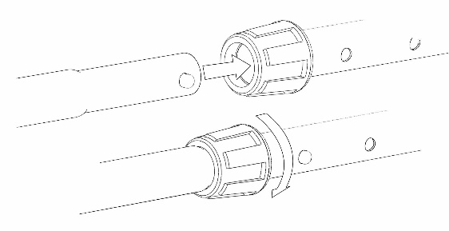
- Insert the upper shaft section into the middle section until the spring lock on the upper section clicks into the hole of the middle section. Turn the clamp (collet) clockwise until the play between the middle and upper sections disappears. Do not overtighten: excessive torque can jam the clamp and cause it to break.

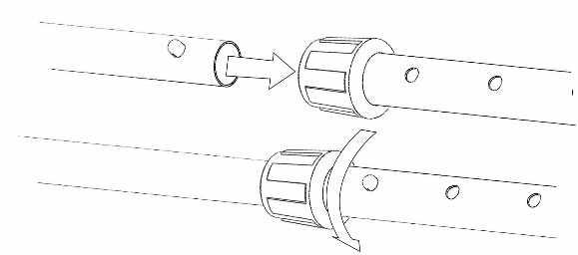
- Insert the lower rod into the middle shaft section and, using the spring lock on the rod and the hole in the middle section, adjust the desired length. Slightly tighten the clamp clockwise; do not tighten it completely to avoid jamming.

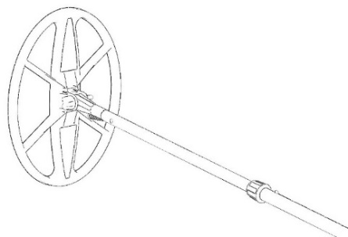
- Secure the coil to the shaft stem using the supplied plastic fastener (bolt + nut) and sealing rubber gaskets, positioning the coil perpendicular to the shaft axis. The cable outlet from the coil housing should be located to the right of the stem axis.

- Wrap the coil cable so that the first loop goes over the stem (see pictures). Incorrect cable wrapping (under the stem) will cause the cable to be severely bent during operation, which can lead to gradual wear at the bend point.
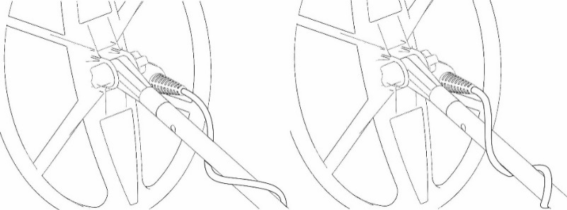

Wrong Right

- Secure the control unit bracket under the armrest of the metal detector on the special screw holders. Tighten the mounting screws using a knife, screwdriver, or by hand.
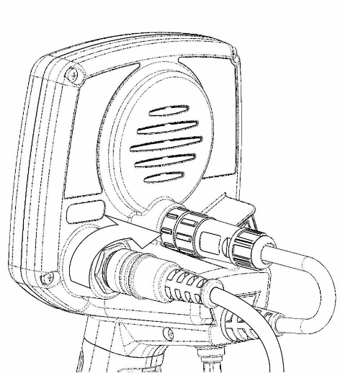
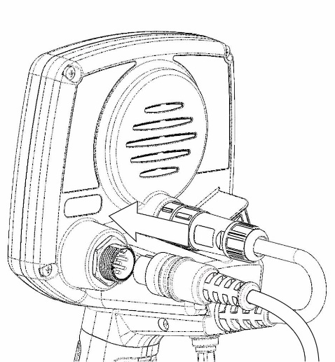
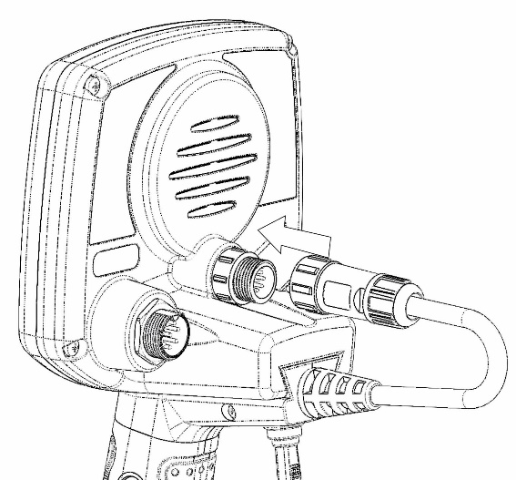

- Place the electronic control unit onto the handle mount and slide it forward until it clicks.

- Connect the power cable to the control unit and tighten the connector nut.

- Connect the coil control-box cable to the control unit and tighten the connector nut.

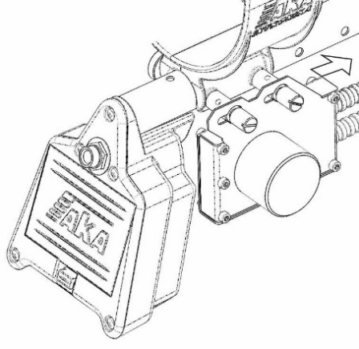
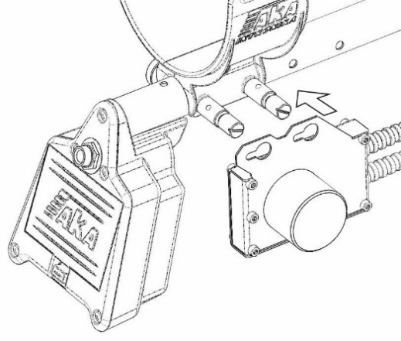

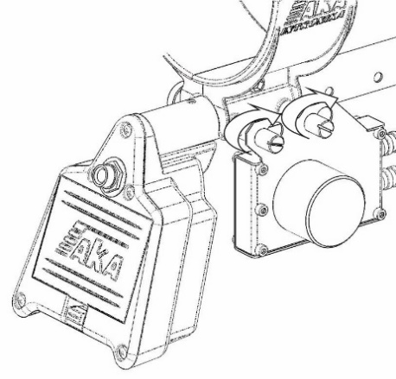

Your metal detector is now assembled.

Controls and Connectors.

On the rear panel of the control unit (see illustrations below):
- Power on/off button.
- Power cable connector.
- Coil control-box cable connector.
- Three-position trigger (toggle) for quick access to frequently used functions.
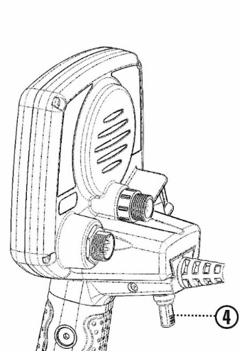
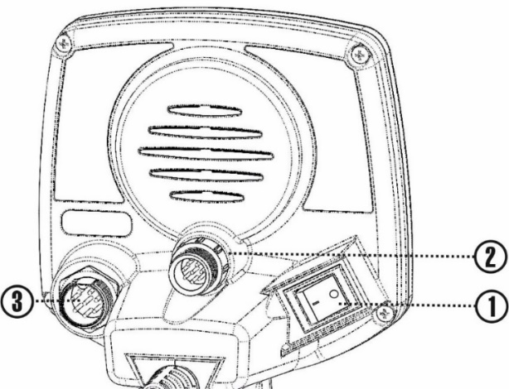

Metal Detector Control Panel
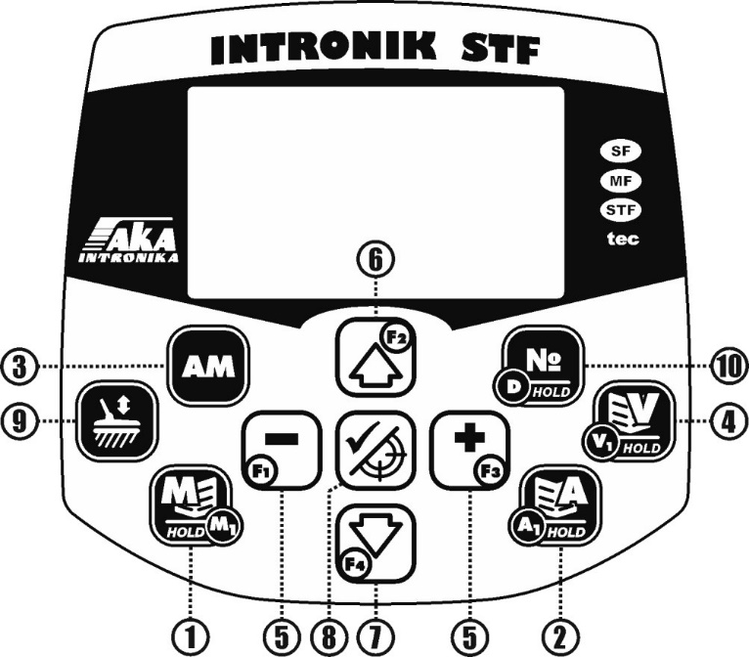
-  - Main search settings menu (short press); Search filters menu (press and hold). Hold while powering on to reset all programs to factory settings.
-  - Audio settings: Main (short press); Tone and tone-boundary adjustments (press and hold). Hold while powering on to enter software update mode.
-  - Enable/disable 2F ID discrimination (short press); Discrimination settings menu (press and hold).
-  - Display settings: Main (short press); Enable/disable display of information items and functions on the screen (press and hold).
-  and  - Adjust setting levels in menus. In Search mode, increases and decreases Speed (see “Settings”). In manual Ground Compensation and Ground Balance, fine-tune the adjustment. Hold while powering on to start coil adaptation.
-  - Move between menu items. In Ground Compensation: increase the ground-signal vector. In Program No. 7 “High Sensitivity 2S” (GB manual): switch between frequency vectors. In Search mode: quick switching between two selected search programs (see “V Menu,” Quick Switch Program).
-  - Move between menu items. In Ground Compensation: decrease the ground-signal vector. In Program No. 7 “High Sensitivity 2S” (GB manual): switch between frequency vectors. In Search mode: enter Pause (freezes the current screen image; the device ignores targets and is silent).
-  - Exit all settings and Ground Compensation to Search mode. In Search mode: enable/disable Pinpoint (precise target location). Hold in Search mode to display a table of the main search settings of the current program.
-  - Enter Ground Compensation. For programs requiring Ground Balance: short press for GB. Press and hold to enter the Ground Evaluation Program.
-  - Program switching mode. Short presses (or [+]) scroll forward; [−] scrolls backward.

Trigger
The trigger is a three-position, momentary (non-latching) toggle: when pushed forward or pulled back and released, it returns to center. Designed for quick access to frequently used functions:

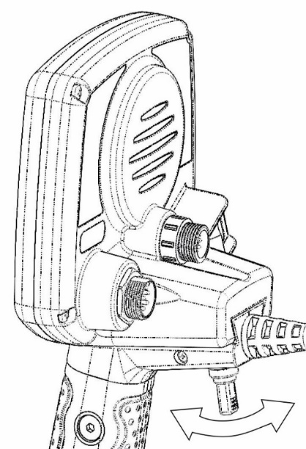
- Push forward and hold — enter Ground Compensation (Programs 1, 2, 3, 4, 6) or Ground Balance (Programs 5, 7); same as . Release when entered the mode. After performing GC/GB, briefly pull the trigger toward you to return to Search.
- Pull and hold — in Search mode, enter Pinpoint (Static); active while held. Release to return to Search. In the menu line, “Static” can be reassigned to “BP Program” (quick access to the selected program) or “Pause.”

- Brief pull — exit all menus and GC/GB to Search (same as ).

On-Screen Information

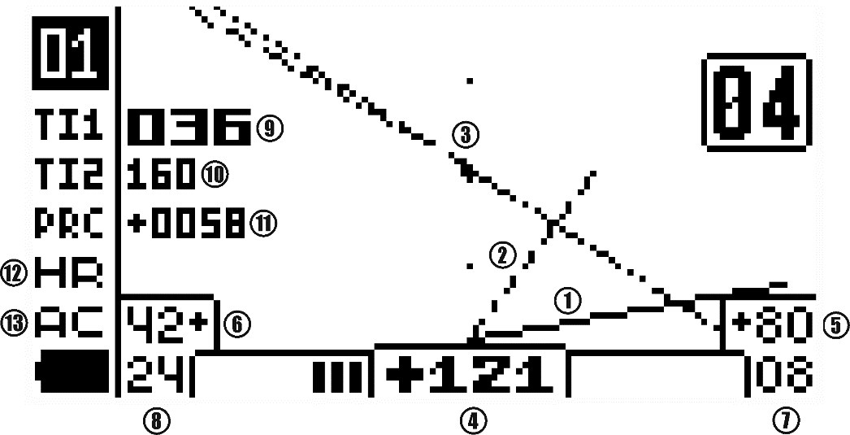
Phase Graphs (Hodographs)
- SFT High-Frequency Hodograph (HF)* — drawn after the target is identified; remains until the identification of the next target.
- SFT Low-Frequency Hodograph (LF)* — drawn after the target is identified; remains until the identification of the next target.
- D Hodograph (2F)* — drawn in real time as the coil passes over the target; disappears after the target leaves the coil field or when the coil stops.
Digital Target Information
- 2F ID * (000…180) - Dual-frequency target ID number; equals the angle of deviation of the D-hodograph from the vertical. The detector assigns a negative value for ferrous targets and a positive value for non-ferrous targets.
- VDI (HF) * (-99…0…+99) – Single-frequency VDI at high frequency.
- VDI (LF) * (-99…0…+99) – Single-frequency VDI at low frequency.
- Signal Rating (HF) * (00…99) – HF target-signal strength (scale + numerical value).
- Signal Rating (LF) * (00…99) – LF target-signal strength (scale + numerical value).
- Ti1 (Target index) * (000…999) - Dual-frequency index reflecting combined size and conductivity.
- Ti2 (Target index 2) * (000…999) – Additional dual-frequency index; correlated with Ti1 helps clarify target nature.
- PRC (Probability coefficient) * (0000…9999) – Helps differentiate signals between clear metallic targets and potentially non-metallic objects.
- HR (Hot Rocks) – appears when the Hot Rocks Filter is enabled; flashes while active.
- AC (Anti Caps) – appears when the Iron Bottle-Cap Filter is enabled; flashes while active.
* - For details, see “On-Screen Target Information. Detailed Explanation”

Preparing the Metal Detector for Search

Coil Adaptation
Coil adaptation is required at first power-on, when changing coils, and after a factory reset. Use the supplied ferrite test piece (or any ferrite sample). Connect the required coil. Keep the device away from metal structures and the ground (there may be unnoticed metal in the soil). Turn it on while holding .
Wait for the digital values of the coil's operating frequencies to appear on the screen. Release the and wait for the adaptation screen to appear.
Smoothly bring the ferrite tip toward the coil center from 50–60 cm to 25–30 cm. Do not bring the supplied ferrite too close.
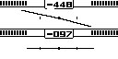
Each time you bring the ferrite test close to the coil, vectors will appear and the HF/LF horizontal scales will begin filling from both sides. Repeat 2–4 times until the scales are full, vectors are horizontal, and you hear two short beeps (adaptation complete). In case of a single beep, repeat the procedure.
Press to enter the Search mode. Adapt again when changing coils, after factory reset, or after a firmware update.
(!) Before searching, perform Ground Compensation at the search site.
(!) If the temperature during adaptation/transport differs greatly from search conditions (e.g., warm car → near-zero outdoors), let the detector equalize to ambient temperature and adapt the coil before searching. If the ambient temperature changes markedly during the hunt (e.g., cold morning → hot day), repeat adaptation.
If no coil is connected, or if a connected coil is not adapted, on power-up you will see “Coil Error.” Check the connection and perform adaptation.

Ground Compensation

Before starting, it is necessary to perform ground compensation directly at the intended search site; this operation is to be saved separately for each search program!
- Turn on the device and find a metal-free spot by sweeping smoothly.
(!) On a clean spot, a device without GC will still not produce sharp rises/falls in the Detection signal during smooth sweeps.
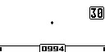
- On a clean spot, turn on the automatic Compensation mode by pressing the device's trigger forward and holding it. Once in the mode, release the trigger (you can also enter the compensation mode by briefly pressing on the device panel).
Pump the coil: raise 10–15 cm, lower to 3–4 cm above the ground. Do not set the coil on the ground or touch rigid vegetation. You will see the ground vector and hear a hum as the coil approaches/moves away. Two horizontal bars at the bottom begin to fill (this is the key sign of GC running, even if the vector is faint on weak ground). Continue until the bars fill fully, the vector auto-aligns strictly vertical, and the ground hum disappears or becomes minimal (on difficult ground it may beat faintly on both up and down strokes). The minimum possible hum (on a specific ground type) with vertical movement of the search coil over the ground is the primary indicator of accurate compensation (even if the vector is small and not clearly visible with a weak ground signal). If the vector does not become vertical on the first pass, continue swinging; the bars will refill and the vector will align, while the ground hum will disappear or become much lower.
Incorrect vs. correct vector:

(!) If the ground-vector trace is very uneven and wavy, that means your ground-signal gain is too high (or there is external EMI). Exit GC (pull trigger or press ), reduce gain, and repeat.
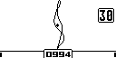
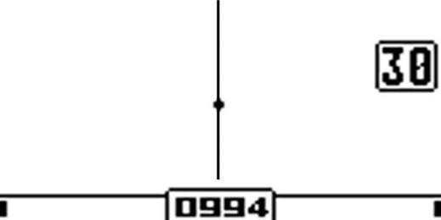
Wrong Right
For deep targets at high sensitivity or difficult ground, automatic GC may be insufficient, or the vector may not become vertical. For maximum precision, switch to manual GC by pressing or  and nudge the vector right or left with the same buttons for the quietest ground response.

A precisely tuned GC yields the minimum possible hum during vertical pumping.
On dry, low-conductivity soils, the ground vector may be barely visible and bars may not fill. Use 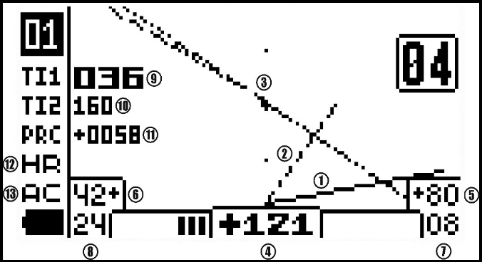 to increase the vector (start bar filling) by amplifying the ground-conductivity signal; use to decrease it. The gain value is shown to the right of the vector. In this way, you will be able to conduct Ground Compensation even on low-conductivity soils or with a weak signal.

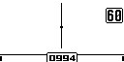
(!) Avoid keeping the ground-conductivity gain above 10 without necessity — it can affect ID on highly conductive ground. If you move from an area where you increased the vector to a more conductive area, reduce the vector with to the screen boundary, or to gain 00 if it still exceeds the boundary. The factory value 30 is optimal for most low-conductivity soils.
If the ground signal is too weak for GC (e.g., at very high Speed), you can lower Speed, perform GC at the increased sensitivity, then raise Speed back.
Quick in-field check: On a clean spot, swing the coil up/down. A strictly vertical on-screen line and no Detection (especially Identification) sound, that means GC is correct. If the vector tilts and Detection/Identification sounds appear on swinging, redo GC. At very high sensitivity, a uniform “beating” Detection sound on swinging is acceptable.

Programs Requiring Ground Balance

Some special additional programs of Intronik STF require a Ground Balance procedure.
Programs No. 5 “Deep Search DL” and No. 10 “Deep Search DS DL” require performing Ground Balance at low frequency first, then Ground Compensation. Enter GB the same way as GC — by pressing or by holding the trigger pushed away from you (release the trigger after the mode opens).
Select a clean patch of ground. In GB, pump the coil vertically (raise 10–15 cm, lower to 3–4 cm above ground). Do not set the coil on the ground or allow the coil to touch the ground or rigid vegetation!!
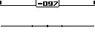
The scales on the screen will fill followed by an audio signal, and the ground vector will auto-align horizontally. At the same time, the coil-movement hum will fade. If the horizontal alignment is not accurate enough in auto mode, press again to switch to manual, and use / to fine-adjust the vector. When GB is complete, exit by pressing (or briefly pulling the trigger). The detector will enter Ground Compensation; perform GC as described above, then return to Search with or a short trigger pull.
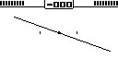

Program No. 7 “High Sensitivity 2C,” Program No. 8 “2C Fast Search,” and Program No. 11 “Real-Time Fast Search” (in HF or LF modes) require Ground Balance on both operating frequencies first, then Ground Compensation. (These programs — except No. 11 in 2F mode — detect targets based only on GB; GC is used to calculate target indexes and for filter operation.) Enter GB as for GC (press or push and hold the trigger; release after entering).
Select a clean patch. Pump the coil as above. You will hear the hum of unbalanced ground, and the scales above the HF and LF vectors will begin filling. Repeat 3–4 times; when enough repetitions are accumulated, the scales will fill completely, the vectors align horizontally, and two short beeps signal completion.
Correct GB is confirmed by the absence of hum while raising/lowering the coil and by strictly horizontal ground vectors on both frequencies. If maximum accuracy in auto mode is not achieved, press again to enter manual GB; adjust the relevant frequency vector with / until it is perfectly horizontal, achieving minimal hum. Switch between frequency vectors with / .

Upon completion, exit with (or brief trigger pull) to GC; perform GC, then return to Search.
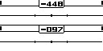
(!) As you move, the ground may change. The detector may produce phantom signals on uneven ground — first in Detection, and with larger changes also in Identification. Re-perform GB if needed.

Ground Evaluation Program

Soil’s magnetic and conductive properties determine depth and identification. Magnetic mineralization reduces depth significantly on single-frequency detectors; Intronik STF’s GC method greatly mitigates this. High conductivity (e.g., on wet marsh floodplains, salt-lake shores, sea surf) can render single-frequency detectors unusable at some point. Being multi-frequency, Intronik STF works effectively on conductive soils in the main GC programs (1, 2, 3, 4, 6, 9 — especially, 11 in 2F, 12).
However, soil magnetism and conductivity still influence results when working with Intronik STF. For maximum efficiency, learn their values on site using Ground Evaluation.
To enter, hold the coil at waist height and press/hold until the program start screen appears. Then press any button to start; the two-frequency GB screen appears. Holding at the waist height, quickly but smoothly lower the coil to 3–4 cm above ground and raise it back; pause 2–3 s. Repeat ~2–3 times (sometimes once is enough) until the ground-signal scales fill, then you will hear the completion tone and the table will appear.
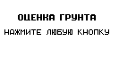

Ground Evaluation Table Data

Amplitude (000…999) – the strength of the ground signal magnetic component.
In search with the Intronik STF metal detector, [ground magnetic mineralization] mainly affects target identification in terms of classification as non-ferrous or ferrous. That is, it affects the "plus" or "minus" value of the 2F ID, whereas it has little effect on detection depth and the actual numerical value of the 2F ID, unlike single-frequency metal detectors.
000-002 – very mild ground. You can almost completely trust the metal detector's identification.
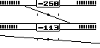
003-006 – ground of low complexity. However, deep non-ferrous targets are often shifted by the ground signal into the ferrous sector, especially during fast coil sweeps. It is recommended to start gaining practical experience on such ground by digging not only clear non-ferrous signals but also "ferrous" signals that raise suspicion (e.g., deep "ferrous" signals with a "non-ferrous" hint in one direction). Recheck targets by alternating the sweep speed (smooth, slow sweeps and slightly faster, shorter ones) while analyzing changes in the identification signal. If necessary, clear bumps and vegetation obstructing the coil from getting close to the ground, or even skim the top layer of soil to create a flat surface for better identification by maximizing coil proximity.
007-010 – medium complexity ground. Identifying deep targets in such ground requires good mastery of the detector and accumulated practical experience, initially gained by digging any targets suspected of being non-ferrous. Recommendations are the same as for grounds 003-006, but accounting for a much greater shift of non-ferrous targets into "ferrous" due to the strong ground signal.
010-030 – highly complex ground. Target identification by the device at depth is very relative.
030-060 and above – very complex ground. With the Intronik STF, you will detect many metal targets inaccessible to most other detectors (except pulse induction). However, identifying even shallow targets requires extensive experience working on such grounds, often at an intuitive level.

Conductivity (00.0…99.9) – level of ground conductivity. To a much lesser extent than magnetism, it also affects identification by adding the ground's conductivity signal to the target signal. This changes the 2F ID of deep targets, potentially giving them values of 000 or 180, which the device will not sound out. For example, a copper coin with a 2F ID of 140 may show a 2F ID of 005 as depth increases in conductive ground.

- 00.0 - +05.0 – low conductivity ground. Has practically no effect on depth and identification. Effective operation is possible not only in the main search programs but also in programs requiring Ground Balance on one or both frequencies, such as the "Deep Search DL" program (No. 5) and the "High Sensitivity 2S" program (No. 7).
- +10.0 - +20.0 – medium conductivity ground. Has a slight effect on depth and shifts the 2F ID of deep targets towards the ends of the scale (001…005 – 170…175). Operation of programs using Ground Balance may be problematic with excessive phantom signals. Their use might be possible with low-frequency coils of the "214" and "108" series. Using Ground Balance programs with coils of the "540" and especially "760" series on such ground is not recommended.
- +25.0 - +35.0 – highly conductive ground. Has a noticeable effect on depth (mainly for "760" and "540" coils) and significantly shifts the 2F ID of targets towards the ends of the scale (001…005 – 170…175). Using programs based on Ground Balance is not recommended. For low-to-the-ground search with high-frequency searchcoils "760" (7/60 kHz) and "540" (5/40 kHz), only programs based on Ground Compensation are recommended: No. 1, No. 2, No. 3, No. 4, No. 6, No. 11 (in 2F mode), No. 12. Operation of low-frequency pairs "108" (1/8 kHz) and "214" (2/14 kHz) in program No. 5 is possible with gain and general settings adequate to the situation. It is not recommended to set the Ground Conductivity Signal Gain (vector) setting in GB higher than 00 during Ground Compensation. If the vector severely doubles or loops during GB, reduce the Gain in the "M" menu of the metal detector.
- +40.0 and above – extremely conductive ground. For low-to-the-ground search, only programs based on Ground Compensation are recommended: No. 1, No. 2, No. 3, No. 4, No. 6, No. 11 (in 2F mode), No. 12. It is not recommended to set the Ground Conductivity Signal Gain (vector) setting in GB higher than 00 during Ground Compensation. If the vector severely doubles or loops during GB, reduce the Gain in the "M" menu of the metal detector.

HF/ LF — phase difference between soil and ferrite at high/low frequency (largely affected by conductivity).

"Quick Start". Factory Programs with the Ground Compensation Method.
GC-based programs are the main search programs of Intronik STF. They work on most weakly and highly mineralized soils and on conductive (“salty”) ground.
Turn on the device and perform the Coil Adaptation*. Choose the program most suitable for your search task from the following:
- Program №1 "Difficult Search Conditions". The most "user-friendly" and easy program for searching, suitable for initial mastering of the metal detector. Use it if these are your first operations with the Intronik STF, or if you lack the experience to configure the device yourself on more sensitive programs in complex ground conditions or areas with tough vegetation. GC-based.
- Program №2 "Standard Search". The most balanced program for depth and speed for general use by experienced operators. GC-based.
- Program №3 "Deep Search". For deep targets in low-trash areas; increased depth, lower sweep speed. GC-based.
- Program No. 4 “Fast Search.” For very trashy sites; separate high-speed algorithm, slightly reduced depth, audio tuned to reduce fatigue from iron trash. GC-based.
- Program No. 9 “Saltwater Beach.” For highly conductive soils up to surf zones; suppresses salt falsing; same fast algorithm as Program 4. (!!!) Perform GC outside the surf zone before searching in surf or with the coil submerged.
Perform Ground Compensation in the selected program*. Start searching. Good luck!
* See “Coil Adaptation.”
* See “Ground Compensation.”

Additional Specialized Factory Search Programs

- Program No. 5 “Deep Search DL.” Focuses on large, highly conductive targets. Sensitivity to small/medium targets equals GC programs when “Sensitivity to Small Targets” is high, but sensitivity to large high-conductive targets is increased. If searching only large targets, reduce Sensitivity to Small Targets. Works using both GC and low-frequency GB. Suitable on low/medium-conductive soils (effect depends on frequency pair; lower pairs are less affected).
(!) Lowering Sensitivity to Small Targets can reduce falsing on medium-conductive soils.
(!!!) Avoid on highly conductive soils.
- Program No. 6 “Deep Program DS.” This unique program allows Intronik STF to perform the tasks of deep-seeking detectors, namely separated and frame-type depth sounders like the Whites TM808. Designed for searching for large objects at depth in the ground, including in conditions littered with small metal objects that shield the signal of the desired targets during a normal search. Search is performed with smooth horizontal sweeps of the coil at a speed of approximately 4 seconds per sweep in one direction. The sweep speed can be slightly decreased or increased depending on the situation. The searchcoil is swept at a height from 5 cm to 1 m depending on the density/size of the surface metallic trash under which targets are being sought. The usual scanning height above the ground at sites of late settlements with a lot of nails and other small metallic trash, based on operator experience, is 40-70 cm.
A sign of a large object is a prolonged Detection signal. Identification by hodographs is similar to other search modes. The sounding of non-ferrous and ferrous target identification depends on the selected "Signal Type" mode in the "A" Menu:
  - 1 Tone — all targets have the same tone.
  - Multi-Tone — iron is sounded with a low tone; non-ferrous targets, with one of four high tones

  - 99 Tones — polyphonic: low for iron; multi-tone for non-ferrous targets.
(!) To master this program and the sound variations of small and large targets, as well as large targets masked by small iron trash, it is highly recommended to practice on a test pit with buried targets before starting to use it (e.g., a simulated coin hoard under several nails, or a helmet for military-themed searchers).
(!) The Deep Search DS program of the Intronik STF can also be used as a regular ground search program. But remember that the identification accuracy of deep targets in this program is somewhat inferior to programs №1, №2, №3, and №5, especially on soils with high magnetic mineralization.

- Program No. 7 “High Sensitivity 2C.” Maximum sensitivity to small, low-conductive targets; slightly higher sensitivity to medium/large high-conductive targets in light soils vs. GC programs. GB-based. Best for dry, non-conductive soils. Not suitable on conductive (“salty”) soils. On damp low-conductive soils, use reduced sensitivity. For maximum depth on large high-conductive targets (in non-conductive soils), lower the HR Filter to the minimum comfortable value.
- Program No. 8 “2C Fast Search.” Similar ground setup to Program 7 but optimized for heavy trash using the same fast algorithm as Program 4. More sensitive to small targets; not recommended on highly conductive (“salty”) soils.
- Program No. 10 “Deep Search DS DL.” Similar to Program 6 but adds low-frequency GB (as in Program 5). This increases sensitivity to large targets but may cause unstable operation on conductive soils (depends directly on the frequency pair used; the lower the pair, the lower the influence).
- Program No. 11 “Real-Time Fast Search” (featuring LF, HF Ground Balance and 2F Ground Compensation modes). For trashy areas with real-time audio preference. Same fast algorithm as Program 4, but real-time audio allows slightly faster operation.
HF mode — high frequency only (GB-based).
LF mode — low frequency only (GB-based).
2F mode — both frequencies (GC-based).
- Program No. 12 “Plowed Field.” For fresh, loose, clumpy plow; especially for small targets. As clods and gaps create signals on any detector, this program uses the fast “trash” algorithm of Program No. 4 but with reduced/disabled filters and full audio for both ferrous and non-ferrous.
(!) Practical rule for program selection: If your detector is too noisy (many false ground signals) in GB programs (“DL” or “2C”), switch to GC programs (1, 2, 3, 4, 6, 12), which can work on the vast majority of complex soils. Namely: №1, №2, №3, №4, №6, №12. In extremely conductive (“salty”) conditions, use Program 9.

Settings
The settings are grouped by menus.
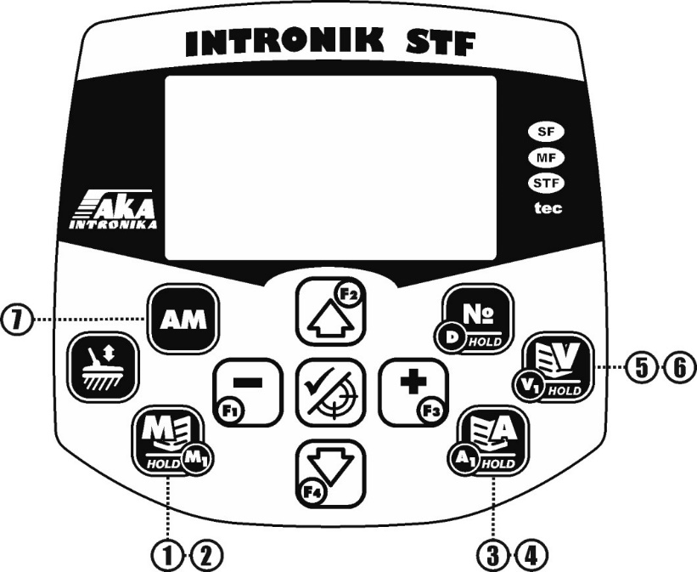

- “M” Menu — short press. Search settings.
- “M1” Menu — long press. Search-filter settings.
- “A” Menu — short press. Main audio settings.
- “A1” Menu — long press. Tone and tone-boundary settings.
- “V” Menu — short press. Main display settings.
- “V1” Menu — long press. Additional display settings.
- “AM” Menu — long press. Discrimination and identification settings.
*** The settings marked with three asterisks appear only in specific special programs, as indicated.

“M” (Main) Menu — Main Search Settings

Access: short press.

Gain (01…27). Overall device sensitivity. Increase or decrease to adjust the range (depth) of target detection. Re-do GC after changing Gain.
(!) Gain amplifies all signals (targets, ground, noise). Choose per soil complexity, vegetation, and EMI. Excessive Gain makes the detector noisy and causes missed deep targets.
(!) The Gain Scale has 27 steps to compensate for sensitivity loss at high Speed or with Operating Frequency shift. E. g., at Speed 8, which is the highest leel, Gain 27 can be usable, while at low or negative Speeds, a much lower maximum Gain is practical.
Speed (−02…00…08). Allows to detect a second and subsequent targets after the coil passes over a target. Higher values allow the detector to separate targets at a shorter distance and higher sweep speed. If depth loss is undesired, increase Gain slightly.
(!!!) For careful deep hunting in clean areas, first reduce Speed (≤02), then adjust Gain for comfort.
(!) Negative speeds (−1, −2) give maximum depth but are suitable only for medium/large, sparse targets in clean, simple ground (except for the special Deep Search DS).
(!) Adjust on the fly with (increase) / (decrease).
*** Sensitivity to Small Targets (01…22) (in DL program only). Noticeably reduces sensitivity to small targets (large targets less so). Useful for deep large coins amid tiny rusty iron fragments. For Program 5, if hunting both large and small targets, set to maximum.
(!) Lowering this value can reduce falsing on medium-conductive soils in Program 5.
Identification Sensitivity (00…20). ID-channel sensitivity. Higher values allow weaker (deeper/smaller) signals to produce an ID tone. ID is post-evaluation, so the tone sounds after the coil passes the target. At 00, the ID channel is off.
(!) Excessive reduction makes the unit quieter but may cause you missing deep/very small targets and worsens separation in trash. Thus, when searching for tiny objects or working on heavy trashed areas, first lower the Gain to align depth and noise level of your detector; avoid setting ID Sensitivity below 13 unless necessary.
Detection Sensitivity (00…20). Real-time Detection channel. Higher values allow you to detect deeper targets, announcing them with a Detection tone. The detection channel works in real time. It starts sounding the presence of a target from the moment of detection until its signal disappears. The highest volume corresponds to the center of the detected target. At setting level "00", the target detection signal is disabled.
(!) Keep this equal to or slightly above ID Sensitivity so deep, non-IDable targets are still detected.
(!) In heavily trashed areas, you can lower Max Detection Volume in the A menu.

Threshold Volume (off…0…20). Constant background hum which helps to hear weak deep signals. Set Off to disable. You may adjusted the pitch to your preference in the "A" Sound menu with the "Detection Tone Frequency" setting (the sound frequency for Detection and Threshold tones is the same).
(!) Use mainly for deep, sparse targets, preferably with headphones, just above audibility. Too high level may result in fatigue and missed faint signals.
Program Reset (Off/On): Reset the current program to factory parameters without affecting others. To do this, use the button to change the value from "Off" to "On", and exit the menu to search mode with the . The current program's settings will return to factory values.

"M1" Menu. Interference and False Signal Filters.
Access: long press .

Frequency Shift (−10…0…+10). Offsets the operating frequency to avoid nearby detectors/EM sources. To shift the frequency press or . Re-do GC after shifting.
(!) With two Intronik STF units of the same pair nearby, shift them in opposite directions. With three of them, leave one at 00 and shift the others differently.
(!) At extreme shifts, sensitivity drops ~3%; to compensate, increase Gain by 1–2 points.
EMI Filter (off…01…30). Suppresses electromagnetic interference (power lines, substations, pipelines, etc.). The higher it is, the better the suppression but slower the response. To compensate for this negative effect, when increasing EMI Filter values, reduce the speed of the searchcoil sweep over the ground.
(!) At filter values above 08, it noticeably worsens the separation of closely spaced targets! Try not to exceed this value (08) unnecessarily in areas where target density (including trash) is more than two per full coil sweep.
- (!) For best interference suppression with the least impact on your metal detector's operation, use the EMI Filter in combination with the Noise Reduction filter. It's better to raise each by a small amount than one by a large amount.

Noise Suppression (−04…00…24). Reduces noise from interference, difficult ground, or when searching in rigid vegetation. Keep low if hunting very small targets (2–4 mm). Increase only if noise prevents detection. For medium/large targets, values up to ~10 are usually fine.
(!) Higher values reduce sensitivity to tiny targets; compensate by slowing the coil speed.
(!) At maximum values, overall sensitivity drops slightly when searching deep targets.
Detection Filter (off… 03). Smooths the Detection signal, removing spikes. This makes the Detection signal more precise and audible but slightly reduces the sensitivity. Factory settings are optimized for the programs' purposes, but can be changed for specific conditions.
GC Filter (on/off). Cleans and smooths the ground vector during GC. This helps perform GB more accurately at high Gain levels and in the presence of interference.
(!) If the ground signal is very weak and EMI is absent, turning this filter off (with the button) increases GC sensitivity to the ground signall.
PRC Filter (off…0050…9999). Probability coefficient-based filter used to reject a wide range of non-metallic signals (mineralization changes, knocks, hot rocks, strong EMI, etc., too difficult for other specific filters). Clear, shallow signals from metallic targets usually have a coefficient close to zero and anyway below 100. Meanwhile, the coefficient from non-metallic signals can range from several hundred up to several thousand. E. g., when setting this filter to 500, the device will accept and emit an identification signal for all targets with a coefficient lower or equal to 500. Targets with a coefficient greater than 500 will be rejected without any signal, marked with the special "HR" sound or as ferrous (depends on the value of the "HR Sound" setting in the "A" menu). To see the PRC (Probability Coefficient) of targets and phantom signals on the screen, enable it in the "V1" menu.
(!) Very deep targets on weak ground, as well as targets lying under hot stones/ceramics can show PRC of several hundreds/thousands and be cut off. Therefore, use it only when necessary, finding a compromise between losing desired targets and the noisiness of the device in complex search conditions. Based on the understanding that on strong false noise (e.g., under power lines), more targets will be missed than the PRC Filter will reject.
HR Filter (off…01…20). Hot-rock and local mineralization-change filter.
(!) If your search is hindered by a large number of hot rocks, local mineralization changes, or any other ground inhomogeneities that trigger the metal detector, use the HR Filter. While sweeping the coil over such an object, raise the filter value until the Identification signal either disappears or is sounded with the special "HR" sound or as ferrous (depends on the value of the "HR Sound" setting in the "A" menu).
(!) High HR Filter values may also cut very deep targets. Therefore, raise its value only in the presence of too many hot rocks and signal ground inhomogeneities, when it is difficult or impossible identify the signals of desired targets or separate them by ear from the hot rock signals.
HR Filter Level (00…20) The "strictness" of the HR Filter. The lower it is, the lower the probability of the filter rejecting metallic targets (but the higher the probability of some rocks being passed into the target signal). The higher it is, the more likely the filter is to reject metallic targets that fall into its zone of operation based on their high-frequency (HF) VDI. The factory value of 07 is optimal in most cases.

“A” Menu — Main Audio Settings
Access: short press .

Volume (01…10). Master volume for all the detector signals. Does not affect Bluetooth aptX LL headphones (volume is controlled on the headphones themselves).
(!) With wired/wireless headphones with a volume control, set detector volume to 02–03 and then adjust on the headphones up to the comfortable level to avoid sound distortion.
ID Volume Boost (005…595). Increases ID-tone loudness and sonority. Set to taste.
Detection Volume Boost (000…600). Increases the Detection tone sharpness. In most cases avoid going above ~070. Set to taste. In most cases, however, it is not recommended raise it above 070.
ID Weak-Signal Volume (01…10). Raises quiet deep ID tones without increasing shallow-target loudness. At max, deep and shallow are equally loud.
(!) Exceeding this parameter also raises the loudness of phantom signals, as well as overall noisiness of your detector. Use high values mainly for deep-target clean-up.
(!) In heavily trashed sites, keep it low to avoid overload from numerous signals.
*** Signal Type (DS & DS DL only):
  - 1 Tone — all targets in one tone.
  - Multi-Tone — low tone for ferrous targets; one of four high tones for non-ferrous ones.
  - 99 Tones — polyphonic; low tone for ferrous targets; multi-tone for non-ferrous ones.
Detection Weak-Signal Volume (01…10). Increasing this value makes quiet signals from deep targets louder.
- (!) High values make it harder to distinguish target depth by ear. Increase only during careful deep target search.
- (!) Keep the value at a minimum in trashy areas.

Detection VCO (Off…01…20): Controls how much the pitch of the Detection signal changes based on target signal strength. Higher values cause a more abrupt change from a low pitch for weak signals to a high pitch for strong/shallow targets or when moving over the target's center. In the "Off" position, the pitch does not change, making it harder to determine target depth and center.
Fe 1 Volume (00…10): Volume of the identification signal for small ferrous targets (pins, scale, small nails) in the VDI sector –99…-70 (sector can be changed in A1 menu). Lowering this value makes lower the volume of the ferrous targets’ signal, while the volume of the non-ferrous ones remains unchanged. At "00", the signal is muted.
Fe 2 Volume (00…10): Volume of the identification signal for medium and large ferrous targets (wrought items) in the VDI sector –70…-14. (sector can be changed in A1 menu). Lowering this value makes lower the volume of the ferrous targets’ signal, while the volume of the non-ferrous ones remains unchanged. At "00", the signal is muted.
(!) Lowering iron volume reduces audio load in trashy areas. Setting Fe 1 volume to zero is useful when searching for desirable wrought iron.
(!) During deep search, lowering iron volume complicates the auditory identification of complex deep signals.
Fe Duration (08…40): Duration of the ferrous target identification signal. Lower values shorten the tone length, increasing comfort in iron trash. Also, if you are not interested in iron objects, lower the ferrous signal to increase comfort of your search.

MAX non-ferrous signal duration (01…15). Maximum duration of the non-ferrous target identification signal. Increasing this value makes non-ferrous signals longer. Adjusted to operator’s preference.

HR Sound (Off/HS/Fe). Tone for targets cut by HS/PRC filters (hot rock, local ground changes, etc). Choose among three options: special short high HR click for “hot rock”, Fe (ferrous tone), or off (no identification signal).
(!) HS is usually preferable — you will hear quiet, non-intrusive clicks and can verify suspicious signals if needed.
(!) The "HR" option is preferable, as it allows you to hear the interference without hindering the search and, if necessary, verify the precision of the filters, analyzing carefully such a signal in case it differs from the rest.

Max Detection Volume (01…10): Limits the maximum volume of the Detection channel signal (also affects Pinpoint volume). Does not affect the volume of weak signals.

(!) Lowering it is useful in trashy areas to reduce ear fatigue. Excessively low values can skew the perception of target depth and size.

(LF / HF / 2F): Selects the source for the identification tone pitch based on VDI:
LF: Low Frequency (for large targets).
HF: High Frequency (for small targets).
2F (Recommended): Averaged value from both frequencies (VDI HF + VDI LF) / 2.
Detection Tone Frequency (0200…0400): Sets the pitch of the Detection and Threshold tones.

ID Signal Type (Standard CT / Poly. CTP / Poly. CTP RT): Changes the type of Identification signal sound.
  - Standard CT: Standard short identification signal (one of 6 tones) combined with the Detection signal. Can be recommended for all search types, especially for deep sparse targets. However, some may find it too busy with sounds in areas with a lot of metal trash if the Detection signal is set too loud (via Max Detection Volume setting).
  - Poly. CTP: Elongated identification signal, tonally colored according to the target's nature. Without the Detection signal. Recommended for those who find Standard CT overly busy with sounds, especially in trashy areas.
  - Poly. CTP RT: The same elongated identification signal, but with the addition of the Detection signal.

GC Completion Sound (on/off). Turns end-of-GC beep.
Overload Sound (on/off). Turns a specific humming sound on or off when very large metal objects are under the searchcoil. An exclamation mark simultaneously appears in the upper right of the screen.
Wireless Connection (On/Off): Turns the Bluetooth wireless communication module on or off, if installed in the device.
(!) The presence of the module can be determined by  sticker on the rear panel of the control box. If absent, the module is not installed. It can be installed by contacting the manufacturer.
(!) For use with Intronik STF, Bluetooth headphones must support the aptX LL (Low Latency) codec. Otherwise, there will be a noticeable audio delay.
(!) To pair new headphones, put them in pairing mode (see headphone manual, usually by holding the power button), then enable Wireless Connection on the detector placed near the headphones. "Searching" → "Connected" will appear. Sound should switch from the speaker to the headphones. If connection fails or there's no sound, move away from other radio wave sources (especially other Bluetooth devices) and retry.
Clear BT Pairings: Clears the Bluetooth module's memory of all previous pairings. Activated with the button. Recommended before pairing new headphones or if connection fails.

“A1” Menu — Additional Audio Settings.

Tone & Boundaries Table

Access: press and hold .
Controls:
 and  buttons switch between tones and boundaries; and adjust the selected parameter. When adjusting tones, each press plays the new pitch. VDI boundaries follow the ID Tone Source setting (HF, LF, or averaged 2F VDI).

“AM” Menu — Discrimination & Identification Settings

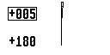
Access: press and hold .
Upper 2F ID Discrimination Boundary. Rejects targets with 2F ID ≤ the set value.
(!) E.g., at 05, all targets with 2F ID ≤ 05 are rejected; > 05 sound with their corresponding tone. Useful to cut out coke (near 00) with minimal impact on other non-ferrous targets.
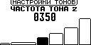
Lower 2F ID Discrimination Boundary. Rejects targets with 2F ID ≥ the set value from 180 and below.
(!) E.g., at 140, all the targets with 2F ID ≥ 140 are rejected (not sounded); < 140 will be sounded with their respected tones. Cutting 0…5 and 175…180 can suppress variable conductive-ground falses — but may also lose tiny low-conductive or very deep useful targets with those 2F IDs.

Enable/Disable 2F ID Discrimination in Search Mode
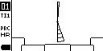
Short press
Shaded sectors appear for the rejected ranges. The Discrimination mode is on.

No Fe Sector (00…90). Forces targets with 2F ID ≤ the set value to sound as non-ferrous, regardless of nature.
(!) E.g., at 30, all targets with 2F ID ≤ 30 sound as non-ferrous. This can help recover tiny low-conductive non-ferrous objects among hot rocks and in highly mineralized ground. Especially applicable with low-frequency coils (e.g., 108, 214 series), where the 0…30 sector rarely contains household iron but may contain many useful low-conductive targets. Less relevant for higher frequency pairs (540 and especially 760).
TI1 Filter (100…500). Above this level, the targets in the iron VDI range are treated as non-ferrous, despite its hodographs and VDI on both frequencies being in the iron region.
(!) Iron with VDI −80…−50 rarely has Ti1 > 250 (usually it is equal to 100–150), while small/low-conductive non-ferrous targets shifted into iron by ground signal typically has Ti1 > 350. Setting the Ti Fe Boundary filter value to 400 will allow you to almost infallibly detect non-ferrous objects shifted by ground signal into the "suspicious iron" area. Lowering the TI1 Filter value will allow you to find even more ground-shifted (and more conductive) non-ferrous targets, but the lower this value, the higher the probability of detecting unwanted iron objects (like rusty needles or small pieces of thoroughly rusted iron) with a non-ferrous signal.
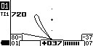
\(!) E. g.: A small target has an in-air VDI of +07 +35 and hodographs in the non-ferrous area. In mineralized ground, its single-frequency VDI can change, shifted by the ground signal, and become -80 -37; the hodographs will also end up in the iron area, where many iron objects with the same VDI reside. Any single-frequency metal detector would consider this target ferrous, and you would miss it. The Intronik STF, by analyzing the target signal on different frequencies, can determine based on the discrepancy between the calculated Target Index Ti1 (too high) and the target's single-frequency VDI that this target is highly likely to be non-ferrous. For this, the TI1 Filter Boundary must be set to a value not higher than -40 (so the HF VDI of -38 falls into the "suspicious iron" zone), and the TI1 Filter not higher than 400 (such low-conductivity targets usually have a Ti1 > 400, while iron with such VDI is < 250, often even < 200).

TI1 Filter Boundary (-80…00): This is the High Frequency (HF) VDI threshold above which the TI1 Filter analyzes signals to match their Target Index Ti1 and VDI on both frequencies.

(!) That is, if the TI1 Filter Boundary is at the factory default of -60, and a ground-shifted non-ferrous target falls into the HF VDI sector above -60 (-60…00, e.g., -59), the TI1 Filter will analyze this target for its possible non-ferrous nature. If the target's VDI falls into the sector below the set boundary (-99…-60, e.g., -61), the TI1 Filter will not engage, even if the Target Index Ti1 is above the set Filter value.
(!) The TI1 Filter Boundary can be raised (up to 00) or lowered (down to -80). The lower the boundary, the more non-ferrous targets shifted into iron can be detected with a non-ferrous sound. But the amount of small rusty iron with a high Ti1 Index in sectors with low VDI also increases.
(!) A simple rule: the lower the TI1 Filter value and the lower the TI1 Filter Boundary, the more shifted non-ferrous targets you find, but the more often small iron is mistakenly sounded as non-ferrous. And vice versa. The higher the TI1 Filter value and the higher the TI1 Filter Boundary, the less erroneous non-ferrous sounding of small iron, but there is a probability of missing some non-ferrous targets shifted into the iron sector.

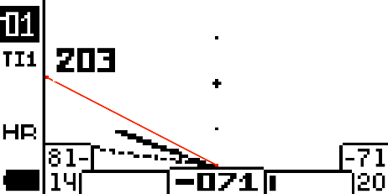
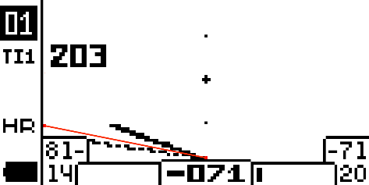
Fig. 1 Fig. 2

Figure 1: The Ti1 Filter Boundary is set to -60. The target's High-Frequency (HF) VDI is -71 and is located below the boundary. The Ti1 Filter will not analyze this target, even if its Ti1 value (e.g., 203) is higher than the filter's threshold setting.
Figure 2: The Ti1 Filter Boundary is set to -80. Since the target's High-Frequency (HF) VDI is -71 and is located above the boundary, the Ti1 Filter will analyze this target. If its Ti1 value (e.g., 204) is higher than the value set in the filter (e.g., 200), the target will be identified as potentially non-ferrous and will be sounded with the first non-ferrous tone.
The boundary line is not displayed on the device's screen and is shown in the illustrations for better visual understanding of its operation.
How to distinguish a ferrous target erroneously sounded as non-ferrous by the Ti1 Filter from a non-ferrous target shifted into the iron sector by ground mineralization (with experience in mastering the device!):
Ferrous Target:
Detection Signal Sound: The target sounds shallow.
Hodographs: The High-Frequency (HF) and Low-Frequency (LF) hodographs remain practically unchanged in position during repeated scans from different angles, resembling a stable "fork" pointing to the left.
Ti1 Value: The Ti1 value fluctuates within relatively small limits.
Fig. 1 Fig. 2
Non-Ferrous Target (shifted):
Detection Signal Sound: The target sounds deep.
Hodographs: The High-Frequency (HF) hodograph significantly changes its position and may loop during repeated scans.
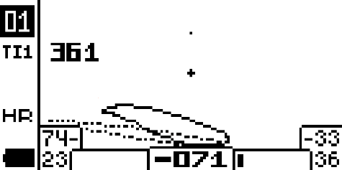
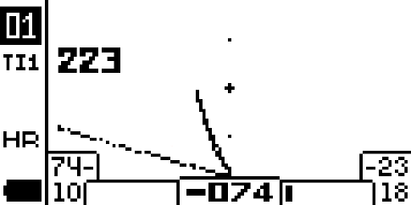
Ti1 Value: The Ti1 value can vary noticeably.
Fig. 3 Fig. 4

Iron Masking (00…15). Balances detection of non-ferrous that sit very close to/under iron and present a composite signal. Lower values emphasize the non-ferrous component but increase the chance of “colored” tones on larger iron. However the probability of erroneously sounding relatively large iron objects with a non-ferrous signal rises as well.
(!) Choose the lowest value that fits the site and your personal preference between detecting non-ferrous targets masked by iron and digging up iron objects sounded by a non-ferrous signal.
TI1 Fe Filter (off…1000). Works by Ti1 to prevent large iron whose LF-VDI = +70…+99 (high-conductive sector) from sounding non-ferrous. Non-ferrous targets in this sector usually have a very low Ti1 Index (010…060), while iron ones are significantly higher (150…300 and more).
(!) E. g.: By setting the TI1 Fe Filter value to 120, you can accurately identify highly conductive non-ferrous targets (e.g., copper and silver coins) by ear among large iron trash, even if their LF VDI falls within the filter's range, as their Ti1 Index is much lower than the set value. Small shallow non-ferrous targets won't be affected, as their high Ti1 Index usually means their LF VDI falls outside the filter's range. Meanwhile, most iron targets that usually sound non-ferrous, falling by LF VDI into this filter's zone, will be sounded with an iron tone, as their Ti1 Index is usually greater than the set value of 120.

(!) This filter can also help maintain high sensitivity settings when searching in tall grass and stiff stubble, as the phantom signals that interfere in such cases are very similar to the iron signals rejected by the TI1 Fe Filter. This is why it is enabled by default in Program №1 "Difficult Search Conditions".

(!) If your configured TI1 Fe Filter still sounds some iron targets as non-ferrous, check the Ti1 Index of these targets (it might be below the filter's set value) and the LF VDI of this iron (it might not fall within the filter's sector between the Left and Right TI1 Fe Boundaries).

(!) Do not use when searching for deep small targets. As depth increases, the VDI of small targets increases, shifting right on the scale, and may fall into the TI1 Fe Filter's zone. Such targets will then be classified as ferrous.

(!) In factory settings, this filter is enabled in Programs №1, №4, №8. When searching for early periods where there are many small desirable targets with high Ti1 Index and little iron that interferes with non-ferrous sounds, we recommend turning this filter off.

TI1 Fe Sound (Fe/Medium Tone). Tone for targets flagged by TI1 Fe.
(!) Without TI1 Fe, iron in +70…+99 sounds like high-conductive coins (copper and silver) which makes harder detection by ear. The Fe sound makes them match surrounding iron. If you still want this iron to stop sounding like copper or large silver coins but want to investigate such signals without missing them by ear, the Medium Tone lets you keep them audible sounding them with the tone of low-conductivity non-ferrous targets.

Left TI1 Fe Boundary (+50…+98) / Right TI1 Fe Boundary (+51…+99): The boundaries between which the TI1 Fe Filter operates.

(!) The TI1 Fe Filter analyzes the Ti1 Index of targets whose Low Frequency (LF) VDI falls within the zone between the Left and Right boundaries. For example, if the Left boundary is +70 and the Right is +99, the filter will analyze only those targets whose LF VDI is greater than or equal to +70 and less than or equal to +99.

Detection Discrimination (On/Off): Discrimination of the Detection signal. This setting allows you to enable or disable the Detection signal for targets rejected in the 2F ID Discrimination sectors or by filters.

(!) Turning off the Detection signal on rejected targets reduces the overall audio load. However, it may change the customary sound picture of the relationship between Detection and Identification signals even for accepted targets.

Fe Cap Discrimination (Off…01…05): Discrimination of iron bottle caps. When enabled, this function replaces the usual non-ferrous identification signal for such targets with an iron tone. The higher the level of this setting, the lower the probability of iron bottle caps sounding with a non-ferrous signal. But a small probability appears of sounding complex and deep non-ferrous targets with an iron tone, which is almost impossible at low levels. Using the Fe Cap Discrimination function is recommended when searching on beaches and public recreation areas.

(!) Also used to reject small rusty pieces of roofing iron and other small flat iron objects.

Fast Identification (Off/On): When enabled, the metal detector spends less time identifying targets, speeding up its operation. However, this may result in some erroneous cases of identifying iron objects with a non-ferrous signal.

“V” Menu — Video/Display Settings

Short press .

D-Graph Scale (1…5). Adjusts D-hodograph size on the detector display.
(!) For very weak deep signals, decrease the scale value to enlarge the D-graph. Can be useful for recovering deep targets with known properties.
(!) In dense shallow trash or EMI, increase the scale value so the D-graph fits and its direction/shape remains readable.
Contrast (01…15). Screen contrast (increase for bright sun).
(!) In bright sunlight, increasing the Contrast setting may improve the visibility of information on the screen.
Backlight Brightness (off, 1, 3). Screen backlight level (increase in low light; decrease at night to avoid glare).
(!) In twilight, increasing the backlight brightness will help improve the visibility of information on the screen. When searching in the dark, if you forgot a headlamp, reducing the backlight brightness will reduce the blinding effect of the screen glow.
Language. Selects the menu language of the device.

(!) To change the language, use the / buttons to select the desired language, and exit to search mode with the button (or a short pull of the trigger towards you).

Display Inversion (on/off). Makes the display background black and the information on it light (negative display).
(!) This display option does not blind with glare when working in complete darkness and is not visible from a distance, although well visible to the operator.
Screen Type (1...4): Selects the variant of information display on the screen. Screen №1 is the classic, most information-rich option. Options №2, №3, and №4 have a larger display of the most necessary information and are suitable for users that find option №1 too small.
Quick Switch Program (01....12): Selection of an "operational" program for quick switching from any program in use. To switch; use the button. To return to the previous program, press again.

"V1" Menu. Additional Video Menu. Managing Information Display on the Screen.
Press and hold .
D Hodograph (On/Off): Turns the display of the D Hodograph on the metal detector's screen on and off.
HF Hodograph (On/Off): Turns the display of the SFT High-Frequency (HF) Hodograph on the screen on and off.
LF Hodograph (On/Off): Turns the display of the SFT Low-Frequency (LF) Hodograph on the screen on and off.
TI1 Display (On/Off): Turns the display of TI1, the two-frequency Target Index, on the screen on and off.
TI2 Display (On/Off): Turns the display of TI2, the additional two-frequency Target Index, on the screen on and off.
PRC Display (On/Off): Turns the display of PRC, the Probability Coefficient, on the screen on and off.

Extended Explanation of Target Information on the Screen

Single-Frequency Hodographs (SFT)
- SFT High-Frequency (HF) Hodograph
- SFT Low-Frequency (LF) Hodograph
Hodographs appear after target identification and remain until the next target is identified.

What Is a Hodograph

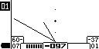
The metal detector coil signal is a vector quantity characterized by amplitude and phase. When any metal object is brought near the coil, the magnitude of this vector changes. The end of this vector describes certain figures (rays, loops, etc.) on the coordinate plane. These figures are commonly called hodographs. When analyzing the hodographs one should remember some general rules:

- Small/medium ferromagnetic (iron) objects: left half of the screen; negative VDI.

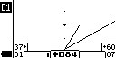
- Non-ferrous objects and large ferromagnetic objects: right half of the screen; positive VDI.
- The larger the reflective area and the higher the conductivity, the more the hodograph tilts right. (Small non-ferrous → Large non-ferrous).
- Large iron objects usually produce a wide loop and may sometimes trigger a non-ferrous ID tone.
- Non-ferrous objects typically produce straight lines or narrow loops.
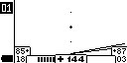
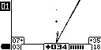
- A strong leftward bend is a sign of ferromagnetic nature even if the ID channel gives a non-ferrous tone. A cross icon in the upper left indicates HF and LF hodographs have swapped (LF above HF). With strong signals, this also indicates iron.
(!) For weak/deep signals or very uneven ground (e.g., in a hole), the cross is not a reliable iron marker.

Small non-ferrous target. Large non-ferrous target.

Analyzing HF and LF Hodographs Together

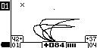
Simultaneous Analysis of HF and LF Hodographs
As a true dual-frequency detector, Intronik STF shows both LF and HF hodographs. Comparing them reveals target nature. For the same alloy, the thinner the target, the faster its LF signal weakens while HF remains relatively strong.
(!) Relative hodograph length reflects relative signal strength at that frequency. That is, the longer the hodograph, the stronger the signal. Conversely, the shorter the hodograph, the weaker the target signal for that frequency.
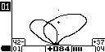
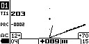
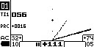
Thin copper plate Small copper coin
Medium copper coin 1-2 mm thin
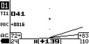
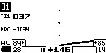
Big and thick copper coin

Also, for low and medium conductivity non-ferrous targets (VDI range 0…+60 on HF), the signal strength on the low (LF) frequency cannot be equal to or greater than that on the high (HF) frequency. It is always less. Therefore, in the combination of hodographs for such non-ferrous target signals, the low-frequency hodograph is always shorter.
At the same time, iron rings and sheets of roofing iron, which can have a similar VDI on the high (HF) frequency (in the range of 0…+50), also have a very strong signal on the low (LF) frequency. The combination of hodographs for such a signal can have a different appearance, making it clear that it is a ferrous target, despite the non-ferrous identification signal. Such a ratio of lengths of high and low frequency hodographs is impossible for non-ferrous metal targets in this VDI range.
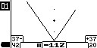
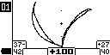

D Hodograph (2F)
Displayed in real time as the coil passes the target; disappears when the target leaves the field or the coil stops.
The deviation angle of the D hodograph from vertical equals the main dual-frequency ID — 2F ID. Iron and non-ferrous objects can share the same numeric 2F ID; the device algorithm assigns plus/minus and the corresponding tone.
- Non-ferrous and rod-shaped iron usually yield a linear D figure.
- Large/flat iron often yields a figure-eight.
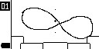
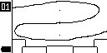
- Decayed/crumbling iron can produce irregular shapes.
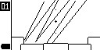

Digital Target Information

2F ID (000…180) – Two-frequency ID (identification number) of the target. Corresponds to the angle of deviation of the target signal's D hodograph from the vertical axis. Depending on the metal detector's identification, it has either a negative (iron targets) or positive (non-ferrous targets) value. Unlike single-frequency VDI, it is much less susceptible to changes due to the influence of ground signal.

Iron targets and non-ferrous metal targets can have the same 2F ID; the plus or minus is assigned by the metal detector's main identification algorithm.
2F ID has a gradation of 180 points, where low-conductivity targets are at the beginning of the scale, and large high-conductivity targets are closer to the end. For example:
  - Salt water – 000
  - Foil – +001…+005
  - Medieval silver coin - +030…+060
  - Medium bronze coin - +090
  - Medium silver coin - +110
  - Large copper coin - +130…+145
On different frequency pairs, the 2F ID for the same target will differ. The general trend is that on a higher frequency pair, all targets increase their 2F ID. This increase is non-linear: significant for small low-conductivity targets and less so for large highly conductive targets and iron. For example:

*Frequency pair 2/14 kHz:*
  - Small medieval silver coin – +034
  - Medium bronze coin – +086
  - Large copper coin – +142
  - Small iron nail - -88

*Frequency pair 5/40 kHz (same targets):*
  - Small medieval silver coin – +061
  - Medium bronze coin – +114
  - Large copper coin – +140
  - Small iron nail - -105

By default, for the Intronik STF, coils of the following frequency pairs are produced:

  - «108» 1kHz – 8kHz (increased current, most complex grounds and deep large targets)
  - «214» 2kHz – 14kHz (large highly conductive targets such as copper and large silver coins, iron relics, but also medium targets)
  - «540» 5kHz – 40kHz (universal pair for searching the entire range from large highly conductive to small and low-conductive)
  - «760» 7kHz – 60kHz (pair for specializing in small and low-conductive coins and jewelry, but also good for medium-sized targets like bronze coins Ø=20-30mm. Can be noisier than other pairs on wet and conductive grounds).

- VDI (HF) (-99…0…+99) – Single-frequency VDI of the target based on high frequency.
- VDI (LF) (-99…0…+99) – Single-frequency VDI of the target based on low frequency.

Common generally accepted single-frequency VDI of targets. The more conductive and larger the target, the higher its VDI in its sector (ferrous or non-ferrous)*. Approximate range:

-99…-85: Very small iron targets, rust, "hot" rocks, ground phantoms.
-85…-60: Small iron.
-60…-40: Wrought nails.
-40…-10: Massive iron products. (Can also be small targets shifted by ground signal)
00: Thin foil.
00…+10: Thin chains, foil lumps, small low-conductivity targets.
+20…+40: Small silver coins.
+40…+60: Small copper coins, medium silver coins.
+60…+80: Large silver coins, medium copper coins.
+80…+85: Large copper coins.
+85…+99: Very deep targets "lying on the ground", cold stones, ground phantoms.

HF-based targets usually have higher VDI than LF-based ones.

** "Higher" in mathematical terms. That is, -40 is a higher VDI in the ferrous sector (-99…00) than -80. And +80 is a higher VDI in the non-ferrous sector 00…+99 than +40.*
- Signal Rating (HF) (00…99) – Strength of the target signal on high frequency.
- Signal Rating (LF) (00…99) – Strength of the target signal on low frequency.

The metal detector target signal strength. Targets at the limit of sensitivity have a rating close to 00. Targets on the surface or large shallow ones have a rating close to 99.
The rating by frequencies depends on the size and conductivity of the targets. For low and medium conductivity non-ferrous targets, the rating on high frequency is always greater than on low frequency. For iron, it's usually the opposite: the rating on low frequency is greater than or equal to the rating on high frequency.
- Ti1 (Target index 1) (000…999) - Two-frequency Target Index. Provides information about the combination of the target's size and conductivity. The smaller the target and the lower its conductivity, the higher its Ti1 value. Conversely, the larger the target and the more conductive its metal, the lower its Ti1 value. For example:
  - Thin gold chain – Ti1 = 750
  - Small cross – Ti1 = 450
  - Small coin – Ti1 = 350-270
  - Wrought nail – Ti1 = 110
  - Large copper coin – Ti1 = 020-040
Used for detecting small non-ferrous targets shifted into the "suspicious iron" sector (See Ti1 Filter in the "AM" Menu. Discrimination menu).

(!) The Ti1 of the same targets may vary slightly when using searchcoils with different frequency pairs.

Ti2 (Target index 2) (000…999) – Additional two-frequency Target Index. When compared with the main Ti1, it can, with experience, provide clarifying information about the target's nature.
  - (!) For iron targets, Ti1 and Ti2 most often have the same value. A clear difference between them can sometimes indicate a non-ferrous nature of the target. Experiment, remember by digging, build a database of such differences.

- PRC (Probability coefficient) (0000…9999) – Target "Probability coefficient". Helps, if necessary, to distinguish between metallic targets’ signals from clear metallic targets from signals of potentially non-metallic origin. Clear signals from metallic targets most often have a PRC of no more than 100. At the same time, signals from coil bumps, electrical interference, false ground signals, and signals from stones can sometimes have a PRC from several hundred to several thousand. By assessing the PRC value of such interfering signals on the metal detector's screen, you can use the PRC Filter (See "M1" Menu, Filters menu) to prevent the device from sounding such signals.
(!) Remember: the weaker the target signal and the stronger the ground signal, the higher the probability that the PRC of metallic targets can greatly increase, and these targets may be rejected by a low PRC Filter setting.

Firmware update
The Intronik STF metal detector features a remote firmware update function. A special USB programmer cable is included for this purpose.
The procedure for updating the device firmware is as follows:
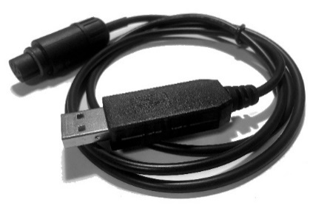
- Download the special update program - AKA Updater at https://aka-md.com/catalog/mdetector/intronik/intronik-stf/
- and place it on your computer's Desktop.
- Download the firmware update file at https://aka-md.com/catalog/mdetector/intronik/intronik-stf/ and put it in a separate folder, for example, named "Intronik".
- Insert the USB programmer cable into the computer's USB port. Upon first connection, the computer will need to install a driver for the new device. This usually happens automatically. If it does not, and the driver was not automatically found on your computer, download it from https://aka-md.com/catalog/mdetector/intronik/intronik-stf/
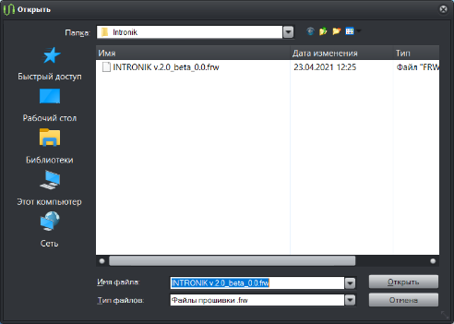
5. Close unused applications. Launch the AKA Updater program and select the update file you previously downloaded and placed in the separate folder.
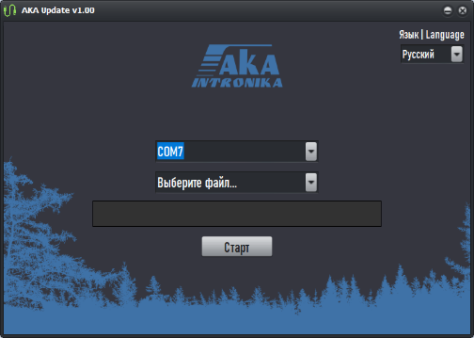

5. Select the COM port where the programmer cable is located.
(!) If the program detects several ports, determine the correct one for the programmer cable as follows: Note down the port numbers, close AKA Updater, then disconnect the programmer cable from the USB port. Launch AKA Updater again and see which port number is now missing from the list. This will be the port number for the programmer cable for all subsequent connections to your computer.
6. Turn on the control unit by holding down the button. The unit will enter firmware update mode, and the corresponding screen will appear. To confirm the action, use to move the selection frame from the "X" (decline) to the "✓" (accept) symbol and press the button. A moving dotted line will appear on the control unit's screen, indicating it is ready for the firmware update.
7. In the AKA Updater program, click the "Start" button. The update progress bar will begin to fill simultaneously on the computer screen and the metal detector's control unit screen. After it completes, the unit will power on with the new firmware version and will immediately show a warning screen about the need to replace the battery pack, as the power voltage from USB is below the minimum operating voltage from batteries.
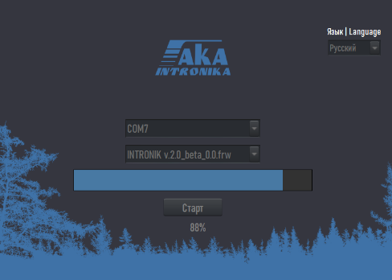
The firmware is successfully updated.
(!) Do not forget to perform Coil Adaptation after updating the firmware.
(!) If the update process stops before completion, or the AKA Updater program displays an error message, turn off the control unit and repeat the update operation starting from step 6 of the instructions.

Warranty Terms
- Warranty repair is performed upon the client presenting a fully completed warranty certificate.
- Delivery of equipment subject to warranty repair to the service center is carried out by the client independently and at their own expense, unless otherwise agreed.
- Warranty obligations do not cover materials and parts considered consumables during operation.

Warranty Void Conditions

Warranty obligations may be voided in the following cases:
- The serial number presented for warranty service does not match the serial number specified in the warranty certificate and/or other written agreements.
- Visible or hidden mechanical damage to the equipment caused by violation of transportation, storage, or operation rules.
- Non-compliance with the Operating Rules and Conditions for this type of equipment, identified during repair.
- Damage to control labels and seals (if present).
- Foreign objects inside the equipment housing, regardless of their nature, unless such possibility is stipulated in the technical documentation and User Manuals.
- Equipment failure caused by force majeure circumstances and/or actions of third parties.

Contacts

International Trade Department: https://aka-md.com/
Email: akadetector@gmail.com
Youtube channel RU: https://www.youtube.com/@akadetector
Youtube channel EN: https://www.youtube.com/@akametaldetectors9409
WhatsApp: https://wa.me/+79037991510
Telegram: https://t.me/+79037991510

Warranty Certificate

The manufacturer guarantees the metal detector's functionality provided the consumer complies with the operating conditions.
The warranty period is 36 months for the electronic unit and 12 months for the coil starting from the date of sale.
Within the warranty period, any discovered manufacturing defects are rectified free of charge by the manufacturer, provided no warranty voiding conditions are met.
To carry out warranty repair, a fully completed warranty certificate must be presented. If the sale date is not indicated, the warranty is calculated from the manufacture date.

Address for filing claims:

Manufacturing and Sales Data

Metal Detector «INTRONIK STF», No. ________________
Coil ________ Frequency Pair /_ kHz No.________________
Manufacture Date « »______________20.
Manufacturer's Stamp
Authorized for operation ____________________ Signature of Responsible Person.
Sale Date «»______________20 .

